Spatial econometrics in R
Katarzyna Kopczewska, associate professor

Class 01 – Visualisation

List of content
# Literature 2
# We are going to produce this kind of analysis 3
# Maps and data – how to get them? 6
# Important packages and links between them 8
# Starting code – reading the data 10
# Basic, but important operations in R 11
# Contour map with centroids 12
# graphical add-ins 13
# Contour map with color layer 14
# with findInterval() from the base:: package 14
# with findColours() 15
# with GISTools::choropleth() 16
# with colorRampPalette() from grDevices:: 17
# Colours 19
# Maps with points 22
# with findInterval() 22
# fragment of the map 24
Extra tasks 25

# Literature
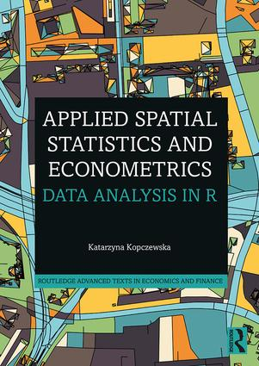 | 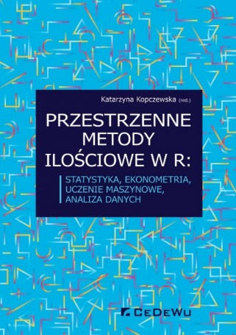 | 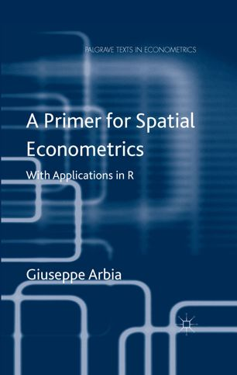
https://www.routledge.com/Applied-Spatial-Statistics-and-Econometrics-Data-Analysis-in-R/Kopczewska/p/book/9780367470760 | https://cedewu.pl/Przestrzenne-metody-ilosciowe-w-R-statystyka-ekonometria-uczenie-maszynowe-analiza-danych-p2865 | https://link.springer.com/book/10.1057/9781137317940
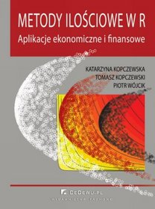 | 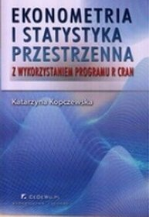 | 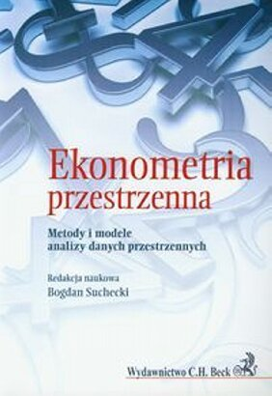
https://cedewu.pl/Metody-ilosciowe-w-R-Aplikacje-ekonomiczne-i-finansowe-wyd-II-p1421 | OLD BOOK, will disappear soon | https://www.ksiegarnia.beck.pl/5519-ekonometria-przestrzenna-metody-i-modele-analizy-danych-przestrzennych-bogdan-suchecki
 | 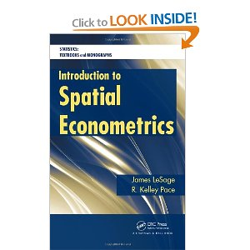 | 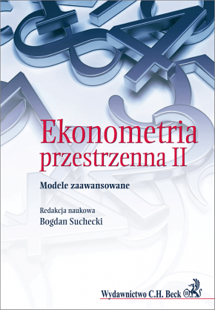
http://www.amazon.com/Applied-Spatial-Data-Analysis-Use/dp/0387781706/ref=sr_1_1?ie=UTF8&qid=1286113109&sr=8-1 | http://www.amazon.com/Introduction-Spatial-Econometrics-Statistics-Monographs/dp/142006424X/ref=sr_1_1?ie=UTF8&s=books&qid=1286113223&sr=8-1 | https://www.ksiegarnia.beck.pl/8396-ekonometria-przestrzenna-ii-modele-zaawansowane-bogdan-suchecki
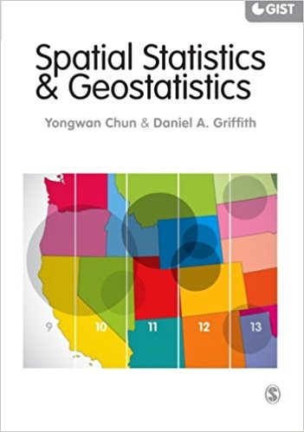 | 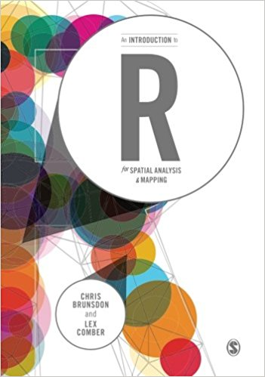 | 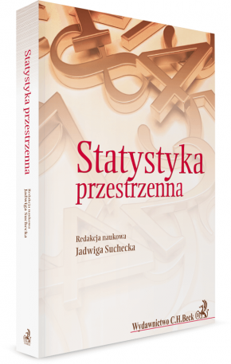
https://www.amazon.de/dp/1446201740/ref=pe_3044161_185740101_TE_item | https://www.amazon.de/dp/1446272958/ref=pe_3044161_185740101_TE_item | https://www.ksiegarnia.beck.pl/11397-statystyka-przestrzenna-metody-analizy-struktur-przestrzennych-jadwiga-suchecka

# We are going to produce this kind of analysis

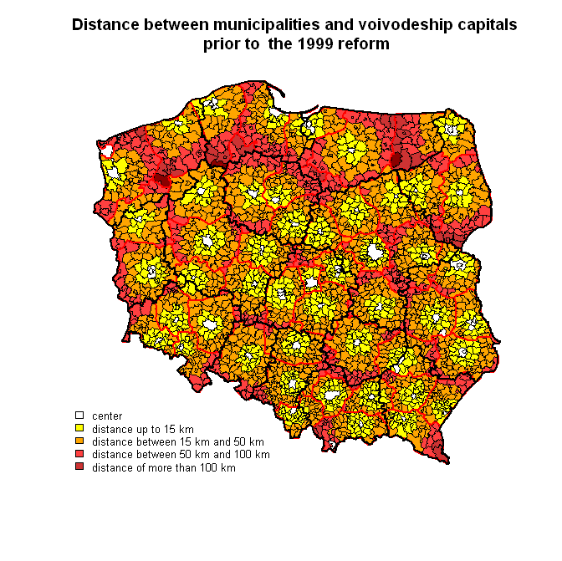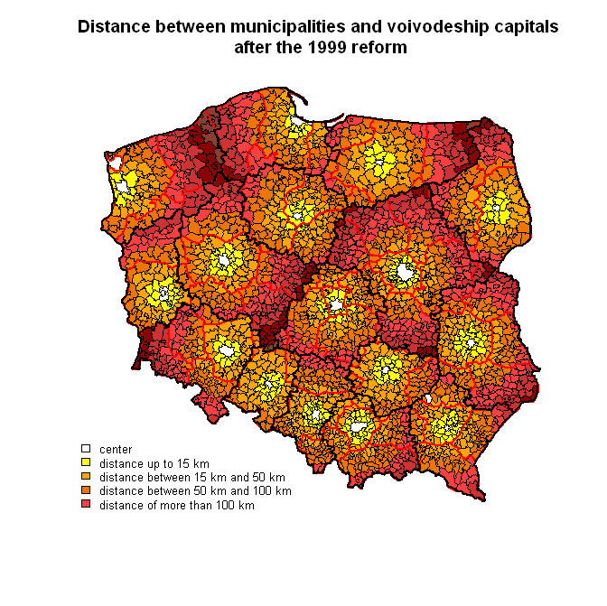
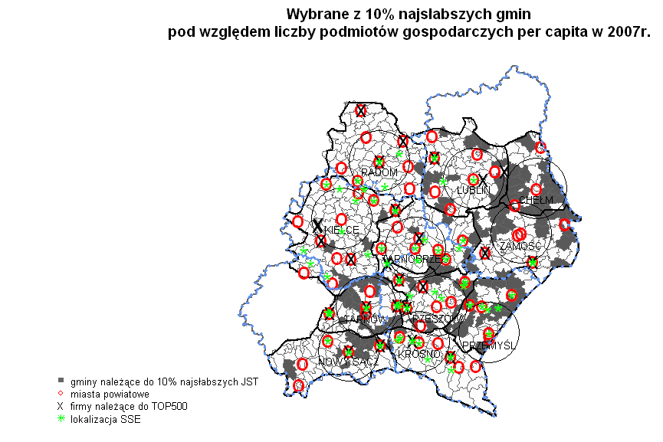
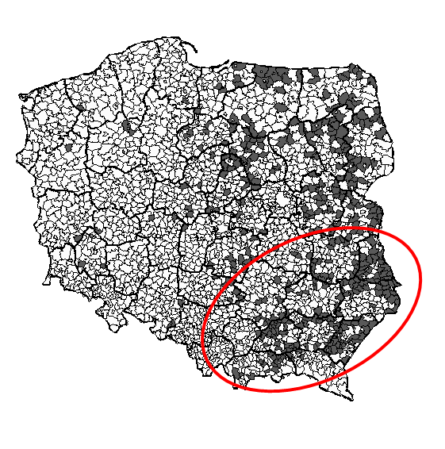

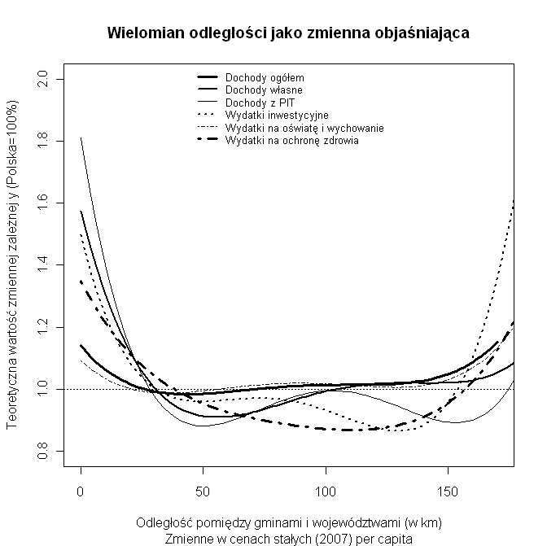

#~~~~~~~~~~~~~~~~~~~~~~~~~~~~~~~~~~~~~~~~~~~~~~~~~~~~~~~~~~

# Maps and data – how to get them?
~~~~~~~~~~~~~~~~~~~~~~~~~~~~~~~~~~~~~~~~~~~~~~~~~~~~~~~~~~~

Dataset: data_nts4_2019.csv

The dataset data_nts4_2019.csv has a panel structure: the data is collected successively for 380 units - poviats (NTS4) in 12 consecutive periods of time (years 2006 - 2017). The data is sorted first after years, then by unit ID (blocked in year groups). The data contains 4560 rows and 39 columns, which gives a total of 177.840 observations. Territorial units - poviats - are ordered as in a poviat map, which is defined by the ID_MAP variable.

Variable name | Description
ID_MAP | Order of spatial units as in shapefile
code_GUS | Code of poviat given by GUS (Polish Statistical Office)
poviat_name1 | Name of poviat (with info on region for duplicated names)
poviat_name2 | Name of poviat (no info on region for duplicated names)
subreg72_name | Name of subregion (division into 72 territorial units)
subreg72_nr | Number of subregion (division into 72 territorial units)
region_name | Name of region (voivodship)
region_nr | Number of region (voividship)
year | year
core_city | Core city of region (1=yes, 0=no)
dist | Distance from poviat to core regional city
XA01 | Total own revenues
XA02 | PIT (Personal Income Tax) revenues
XA03 | CIT (Corporate Income Tax) revenues
XA04 | Total revenues
XA05 | Investment expenditures
XA06 | Inhabitants total
XA07 | Inhabitants in pre-productive age <17
XA08 | Inhabitants in productive age
XA09 | Inhabitants in post-productive age
XA10 | Inhabitants per 1 km2
XA11 | population density of built-up and urbanized area (people / km2)
XA12 | Registered unemployed labour force
XA13 | Firms per 10 thous. Inhabitants in productive age
XA14 | Salaries Poland=100%
XA15 | Employed in total
XA16 | Employed in agriculture, forestry, hunting and fishing
XA17 | Employed in industry and construction
XA18 | Employed in trade, repair of motor vehicles; transport and storage; accommodation and gastronomy; information and communication
XA19 | Employed in financial and insurance activities; real estate market service
XA20 | Employed in other services
XA21 | Unemployment rate
XA22 | Unemployment rate Poland=100%

Source of maps:

- http://www.diva-gis.org/gData
shapefile maps for whole world, for Poland contours of PL, voivodships and poviats (3 poviats are missing)
- Small files, quick downloading

- http://www.codgik.gov.pl/index.php/darmowe-data/prg.html
--> Central Center for Geodetic and Cartographic Documentation / Centralny Ośrodek Dokumentacji Geodezyjnej i Kartograficznej
very large zip folders (372 MB)

http://www.gis-support.pl/baza-wiedzy/data/data-do-pobrania/
- Smaller files, the same as at codgik.gov.pl

About shapefile:
http://en.wikipedia.org/wiki/Shapefile

About projections:
https://mgimond.github.io/Spatial/coordinate-systems-in-r.html
https://www.nceas.ucsb.edu/~frazier/RSpatialGuides/OverviewCoordinateReferenceSystems.pdf

# Important packages and links between them

spdep: Spatial Dependence: Weighting Schemes, Statistics and Models
A collection of functions to create spatial weights matrix objects from polygon contiguities, from point patterns by distance and tessellations, for summarizing these objects, and for permitting their use in spatial data analysis, including regional aggregation by minimum spanning tree; a collection of tests for spatial autocorrelation, including global Moran's I, APLE, Geary's C, Hubert/Mantel general cross product statistic, Empirical Bayes estimates and Assunção/Reis Index, Getis/Ord G and multicoloured join count statistics, local Moran's I and Getis/Ord G, saddlepoint approximations and exact tests for global and local Moran's I; and functions for estimating spatial simultaneous autoregressive (SAR) lag and error models, impact measures for lag models, weighted and unweighted SAR and CAR spatial regression models, semi-parametric and Moran eigenvector spatial filtering, GM SAR error models, and generalized spatial two stage least squares models.

spatialreg: Spatial Regression Analysis
A collection of all the estimation functions for spatial cross-sectional models (on lattice/areal data using spatial weights matrices) contained up to now in 'spdep', 'sphet' and 'spse'. These model fitting functions include maximum likelihood methods for cross-sectional models proposed by 'Cliff' and 'Ord' (1973) and (1981), fitting methods initially described by 'Ord' (1975). The models are further described by 'Anselin' (1988). Spatial two stage least squares and spatial general method of moment models initially proposed by 'Kelejian' and 'Prucha' (1998) are provided. Impact methods and MCMC fitting methods proposed by 'LeSage' and 'Pace' (2009) are implemented for the family of cross-sectional spatial regression models. Methods for fitting the log determinant term in maximum likelihood and MCMC fitting are compared by 'Bivand et al.' (2013), and model fitting methods by 'Bivand' and 'Piras' (2015); both of these articles include extensive lists of references. 'spatialreg' >= 1.1-* correspond to 'spdep' >= 1.1-1, in which the model fitting functions are deprecated and pass through to 'spatialreg', but will mask those in 'spatialreg'. From versions 1.2-*, the functions will be made defunct in 'spdep'.

rgdal: Bindings for the Geospatial Data Abstraction Library
Provides bindings to Frank Warmerdam's Geospatial Data Abstraction Library (GDAL) (>= 1.6.3) and access to projection/transformation operations from the PROJ.4 library. The GDAL and PROJ.4 libraries are external to the package, and, when installing the package from source, must be correctly installed first. Both GDAL raster and OGR vector map data can be imported into R, and GDAL raster data and OGR vector data exported. Use is made of classes defined in the sp package. Windows and Mac Intel OS X binaries (including GDAL, PROJ.4 and Expat) are provided on CRAN.

maptools: Tools for Reading and Handling Spatial Objects
Set of tools for manipulating and reading geographic data, in particular 'ESRI Shapefiles'; C code used from 'shapelib'. It includes binary access to 'GSHHG' shoreline files. The package also provides interface wrappers for exchanging spatial objects with packages such as 'PBSmapping', 'spatstat', 'maps', 'RArcInfo', 'Stata tmap', 'WinBUGS', 'Mondrian', and others.

sp: Classes and Methods for Spatial Data
Classes and methods for spatial data; the classes document where the spatial location information resides, for 2D or 3D data. Utility functions are provided, e.g. for plotting data as maps, spatial selection, as well as methods for retrieving coordinates, for subsetting, print, summary, etc.

RColorBrewer: ColorBrewer Palettes
Provides color schemes for maps (and other graphics) designed by Cynthia Brewer as described at http://colorbrewer2.org

classInt: Choose Univariate Class Intervals
Selected commonly used methods for choosing univariate class intervals for mapping or other graphics purposes.

# tracking links between packages

install.packages("miniCRAN")
library(miniCRAN)
tags<-"sp" # indication of packages for which links are to inspect
pkgDep(tags)
dg<-makeDepGraph(tags, depends=TRUE, suggests=TRUE, enhances=TRUE)
plot(dg, legendPosition=c(-1, 1), vertex.size=10, cex=1.4)

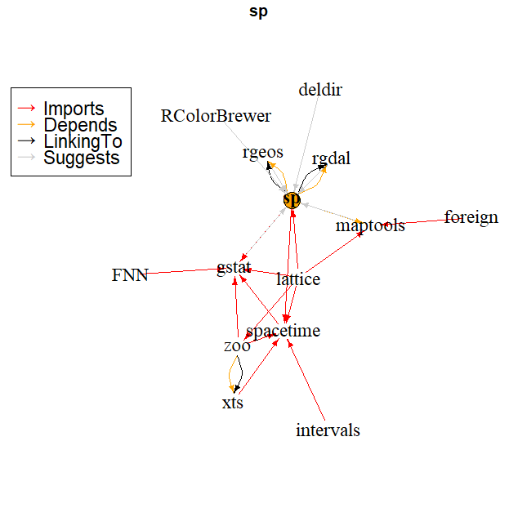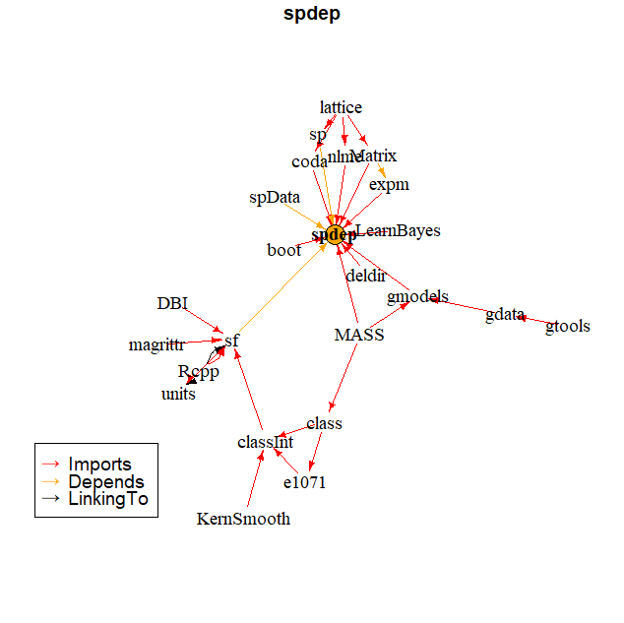

# Starting code – reading the data

# installing necessary packages
install.packages("spdep") # install package
library(spdep)
library(rgdal)
library(maptools)
library(sp)
library(RColorBrewer)
library(classInt)
library(GISTools)
library(maps)
search() # see active packages

# setting access path to Working Directory
# notice: change \ into /
getwd()
setwd("C:/your_folder")
getwd()

# reading maps with rgdal::
pl<-readOGR(".", "Panstwo") # 1 jedn.
voi<-readOGR(".", "wojewodztwa") # 16 jedn.
pov<-readOGR(".", "powiaty") # 380 jedn.

# changing projections
pl<-spTransform(pl, CRS("+proj=longlat +datum=NAD83"))
voi<-spTransform(voi, CRS("+proj=longlat +datum=NAD83"))
pov<-spTransform(pov, CRS("+proj=longlat +datum=NAD83"))

plot(pl)
plot(voi)
plot(pov)
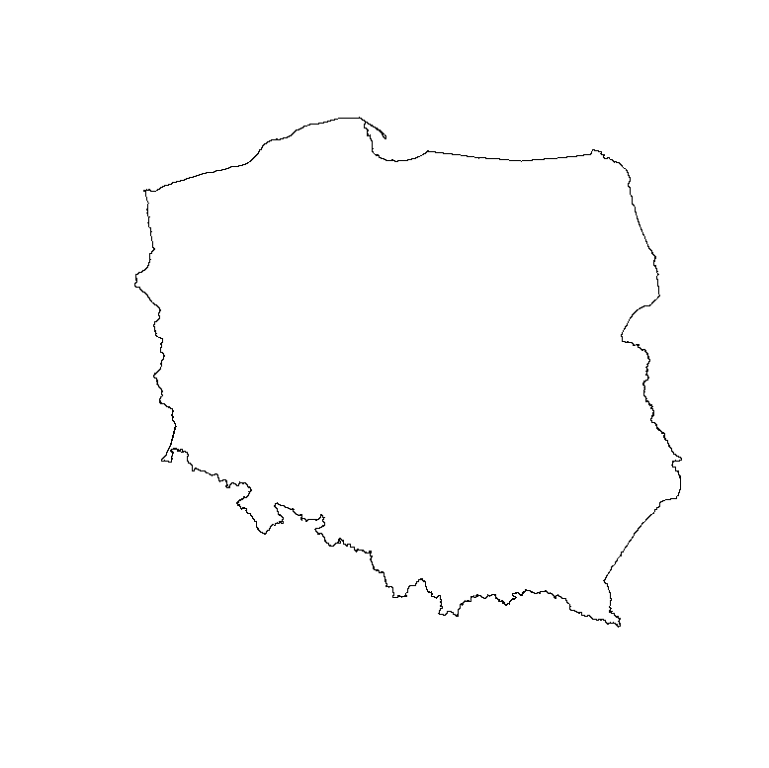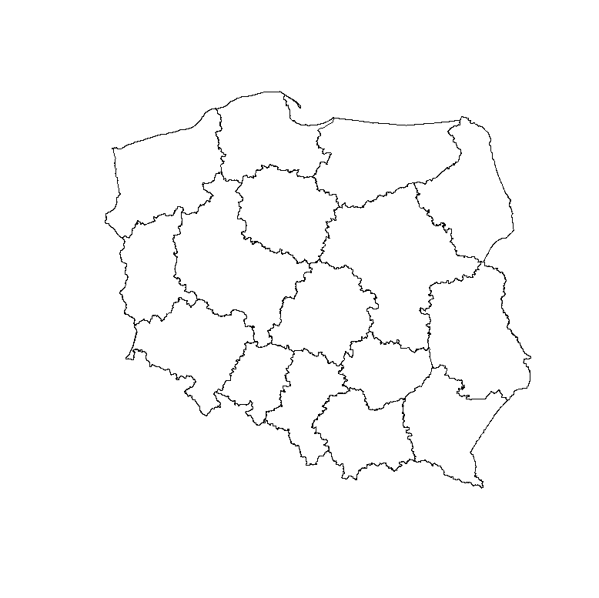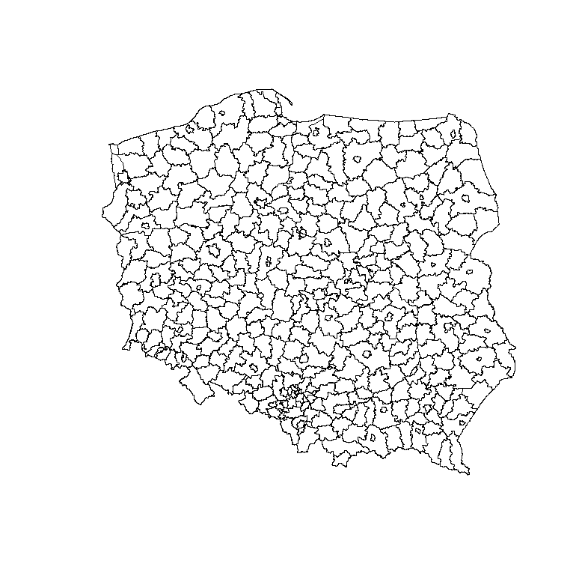

# reading data into dataframe
data<-read.table("data_nts4_2019.csv", sep=";", dec=",", header=TRUE)
summary(data)
dim(data)

# extracting database from shapefile
pov.df<-as.data.frame(pov)

# przeglądanie danych
summary(data)
names(data)

# Basic, but important operations in R

# overview of data
summary(data) # summarizing the data
names(data) # checking the heads of data
class(data) # checking the class of object
head(data) # displaying first six operations
tail(data) # displaying last six operations

summary(data$XA03) # summary of selected variable
summary(data$XA03[data$rok==2006]) # …of selected variable in given year
levels(data$region_name) # levels of qualitative variable

# data subset
# subset for given year and selected level of qualitative variable
sub06<-data[data$year==2006 & data$region_name=="Pomorskie",]
sub06
summary(sub06)

data1<-data[1:10, c(-3, -7)] #rows from 1 to 10, without columns 3 & 7
For conditions use:
- sign & as AND
- sign | as OR

# adding new variable into dataset
# employed (XA15) related to population in productive age (XA08)
data$XA15pc<-data$XA15/data$XA08
summary(data$XA15pc)

# class of objects
class(data)
class(pov)

# going inside spatial objects
levels(pov@data$jpt_nazwa_) # levels of spatial units from shapefile database
str(pov)
slotNames(pov)
slotNames(pov@polygons[[1]]) # slot names within the slots
pov@bbox
lapply(pov@polygons, slot, "ID")
unlist(lapply(pov@polygons, slot, "ID"))

# Contour map with centroids

Plot multilayer contour administrative map. Add centroids as points.

# spatial coordinates of poviat centroids
crds<-coordinates(pov)

# contour map
plot(pl, lwd=3)
plot(pov, add=TRUE)
plot(voi, add=TRUE, lwd=2)
points(crds, pch=21, bg="red", cex=0.8)

# labels of regions
plot(pov)
pointLabel(crds, as.character(pov.df$jpt_nazwa_), cex=0.6)

plot(pov)
text(crds, as.character(pov.df$jpt_nazwa_), cex=0.6)

# interactive edition of poviat’s names
plot(pov)
identify(crds, labels=as.character(pov.df$jpt_nazwa_))

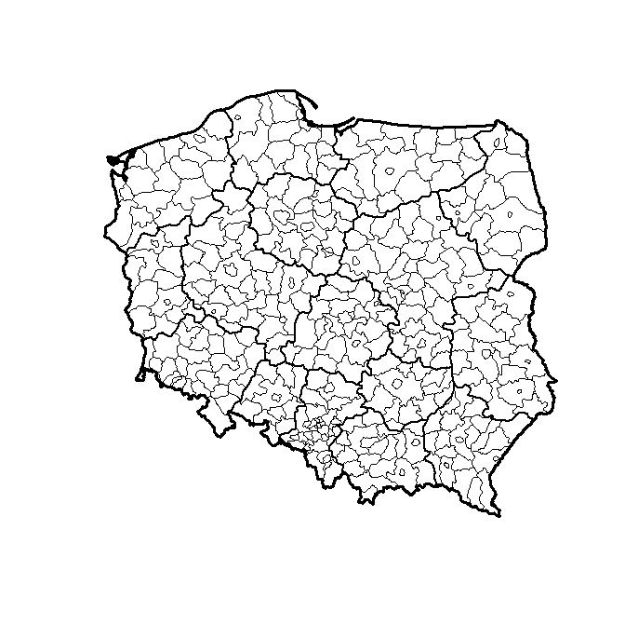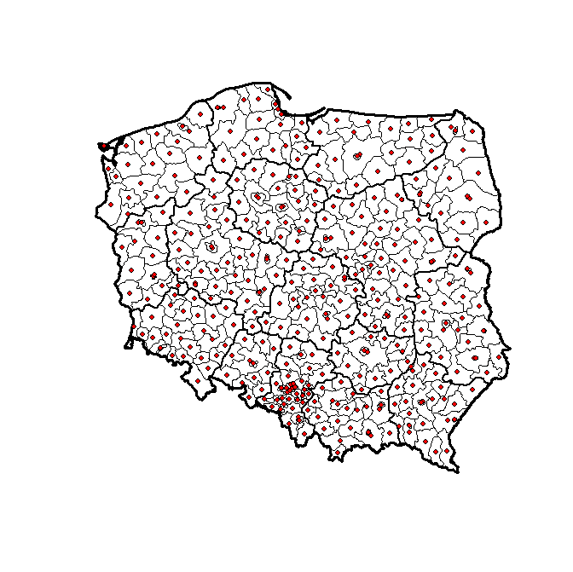

# graphical add-ins

Basic contour maps can be enriched with additional graphical elements. These are, for example: map scale - drawn with the map.scale() command from the maps:: package, arrow pointing north - drawn by north.arrow() from the GISTools:: package, map scale applied with the degAxis(1) and degAxis(2) from the sp:: package, a rose showing compass directions - drawn by compassRose() from the sp:: package, geographic grid - drawn by plot(gridlines()) from the sp:: package.

plot(pov)
map.scale(x=14.5, y=49.3, ratio=FALSE, relwidth=0.2) #using maps::
north.arrow(xb=15.9, yb=49.8, len=0.1, lab="N", cex.lab=0.8, col='gray10') # using GISTools::

plot(voi)
degAxis(1) # using sp::
degAxis(2)
compassRose(15, 49.7,rot=0,cex=1) # using sp::
plot(gridlines(voi), add = TRUE) # using sp::

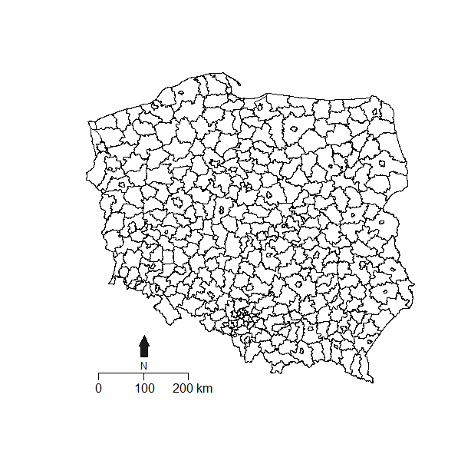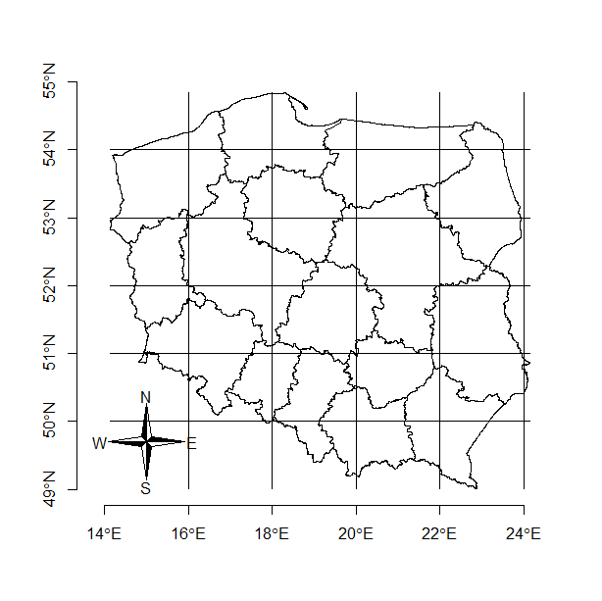

# Contour map with color layer

Plot poviat map with layer for voivoidship id

# with findInterval() from the base:: package

variable<-data$region_nr[data$year==2015]
brks<-(0:16)*2
brks
#[1] 0 2 4 6 8 10 12 14 16 18 20 22 24 26 28 30 32

# use colours
cols<-c("blue3", "cornflowerblue", "seagreen1", "yellow", "chocolate1", "orangered1", "brown3", "coral4", "salmon4", "aquamarine3", "darkgreen", "chartreuse3", "cyan4", "darkred", "darkviolet", "cadetblue3", "blue")

par(mar=c(1,1,1,1)) # contour plot & each region with own colour layer
plot(pov, col=cols[findInterval(variable, brks)], border="grey80")
plot(voi, add=TRUE, lwd=1)
par(mar=c(5,4,4,2))

# labels of provincial names
crds.voi<-coordinates(voi)
voi.df<-as.data.frame(voi)
text(crds.voi, label=voi.df$jpt_nazwa_, cex=0.7, font=2)

# use shading
dens<-(2:length(brks))*3

par(mar=c(1,1,1,1))
plot(pov, density=dens[findInterval(variable, brks, all.inside=TRUE)], border="grey80")
plot(voi, add=TRUE, lwd=1)
par(mar=c(5,4,4,2))

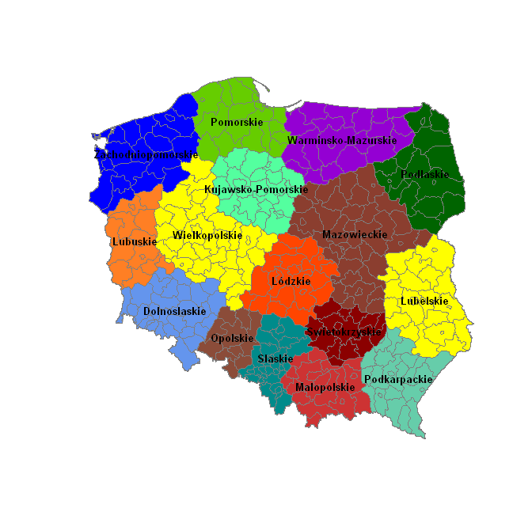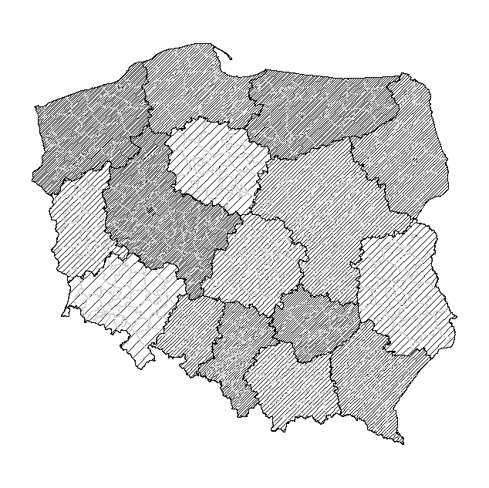

# with findColours()

Plot poviat map with layer for unemployment rate (XA21)

library(classInt)
variable<-data$XA21[data$year==2015]
summary(variable)

intervals<-8
colors<-brewer.pal(intervals, "BuPu") # choice of colors
classes<-classIntervals(variable, intervals, style="fixed",
fixedBreaks=c(0, 5, 10, 15, 20, 25, 30, 35, 40))
color.table<-findColours(classes, colors)

plot(pov, col=color.table)
plot(voi, lwd=2, add=TRUE)
legend("bottomleft", legend=names(attr(color.table, "table")),
fill=attr(color.table, "palette"), cex=0.8, bty="n")
title(main="Unemployment rate in poviats in 2015")

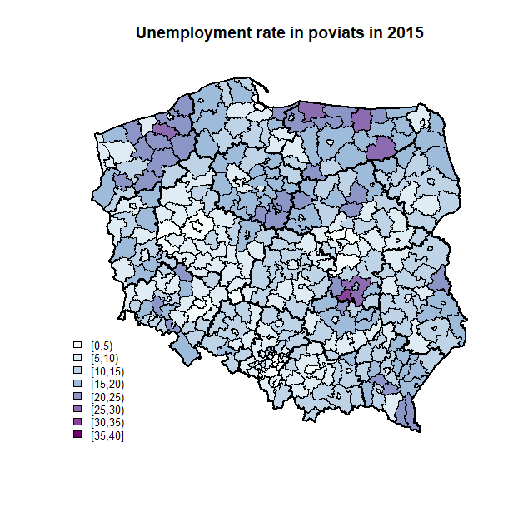

# with GISTools::choropleth()

Plot a map of distances between poviats and regional main cities

library(GISTools)
variable<-data$dist[data$year==2015]
summary(variable)

# almost all goes automatically
choropleth(pov, variable)

# with setting some parameters
shades<-auto.shading(variable, n=6, cols=brewer.pal(6, "Purples"))
choropleth(pov, variable, shading=shades)

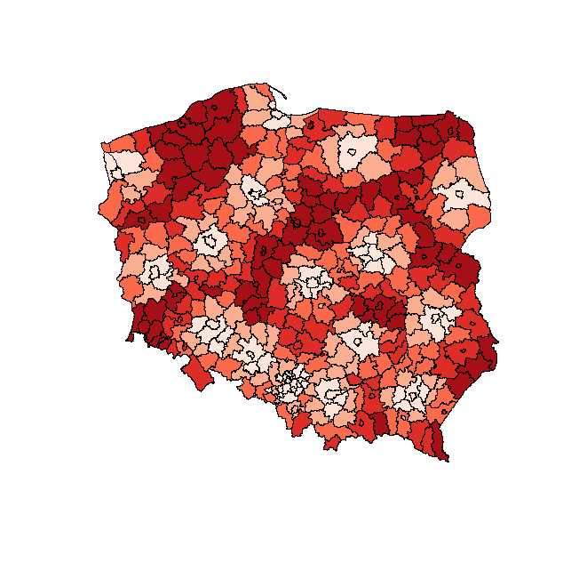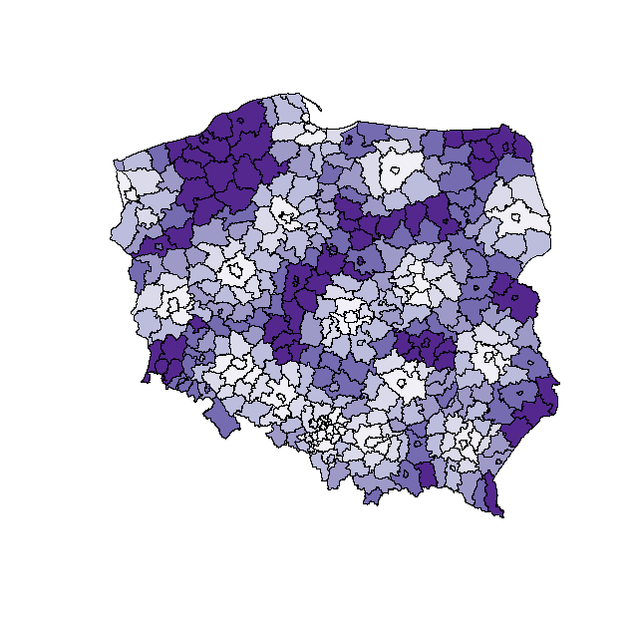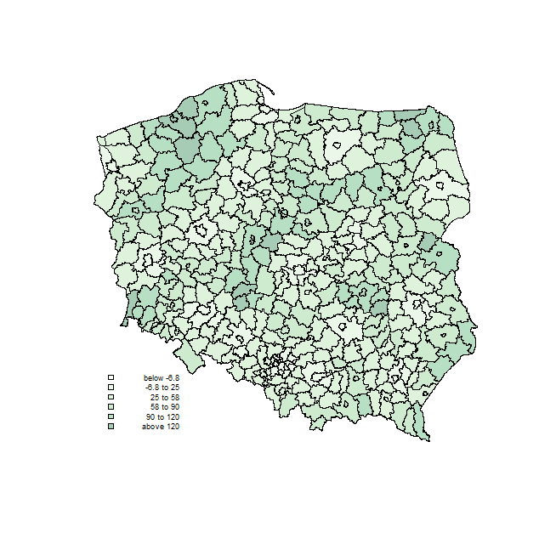

# division into intervals by mean and std.dev,
shades<-auto.shading(variable, n=6, cols=add.alpha(brewer.pal(6, "Greens"), 0.35), cutter=sdCuts)
choropleth(pov, variable, shading=shades)
choro.legend(14.3, 50.2, shades, under="below", over="above", between="to", cex=0.6, bty="n")
savePlot(filename="Fig1", type="jpg")

# with colorRampPalette() from grDevices::

For a defined number of intervals (nclr - number of colors), the palette of shades is chosen (here Reds). The brewer.pal() command creates a color vector. Next, the colorRampPalette() command from the grDevices:: package "pulls" the color vector and creates an interpolating function (fillRed) that continuously transcodes the variable values into a color vector. The colcode object contains the names of colors that are drawn with the ordinary plot() command. The first county layer (NTS4) contains information on the colors of the regions according to the colcode object, while the county contours were omitted by the option lty=0. The second regional layer (NTS2) has been superimposed on the previous graph thanks to the add=TRUE option, while voivodship contours are drawn in light gray (border = "gray60"). The colorlegend() command from the shape:: package creates a vertical bar that specifies the color scale. The way of applying the scale of the map and the direction of the rose is explained earlier.

library(shape)
variable<-data$XA21[data$year==2015]
maxy<-40
breaks<-c(0, 5, 10, 15, 20, 25, 30, 35, 40) # used in the legend
nclr<-8
plotclr<-brewer.pal(nclr, "Reds") # from the RColorBrewer package
fillRed<-colorRampPalette(plotclr) # from the grDevices package
colcode<-fillRed(maxy)[round(variable) + 1] # fillRed is a function

plot(pov, col=colcode, lty=0)
plot(voi, add=TRUE, lwd=1, border="gray60")

maps::map.scale(x=18.0, y=49.3, ratio=FALSE, relwidth=0.2, metric=TRUE)
compassRose(16, 49.8,rot=0,cex=1) # from the sp package

colorlegend(posy=c(0.05,0.9), posx=c(0.9,0.92), col=fillRed(maxy), zlim=c(0, maxy), zval=breaks, main.cex=0.9) # from the shape:: package

title(main="Unemployment rate in 2015 r.", sub="At the NTS4 level, according to the Central \n Statistical Office data")

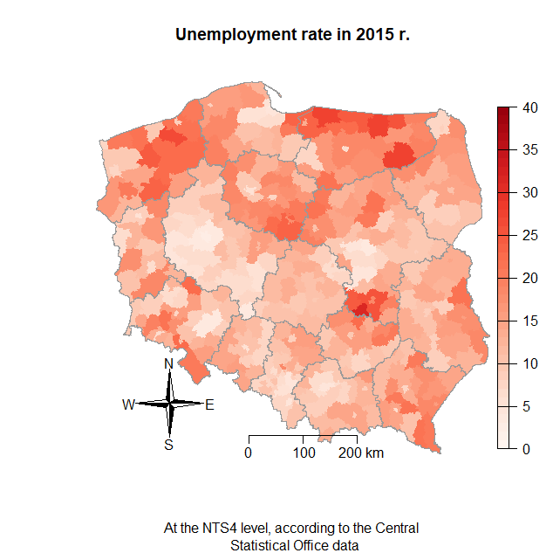

# Colours

Colours palettes can be plotted with: image(), plot() for raster()
One can display colours using rgb(), colors(), demo("colors")

# generating random colors and plotting with image()
a<-rgb(runif(21,0,1), runif(21,0,1), runif(21,0,1))
a
a.dim1<-length(a)
image(1:a.dim1, 1, as.matrix(1:a.dim1), col=a, xlab="grDevices::rgb() / random colors ") # vertical stripes with colours

# plotting names of colours in raster
colors() # the first few lines of color names
library(raster)
r<-raster(xmn=0, xmx=22, ymn=0, ymx=30, nrows=30, ncols=22)
r[]<-1:660
plot(r, col=colors()) #rasters (cells) with colours
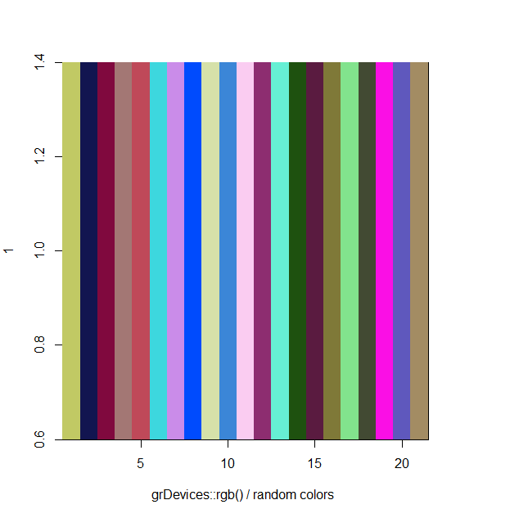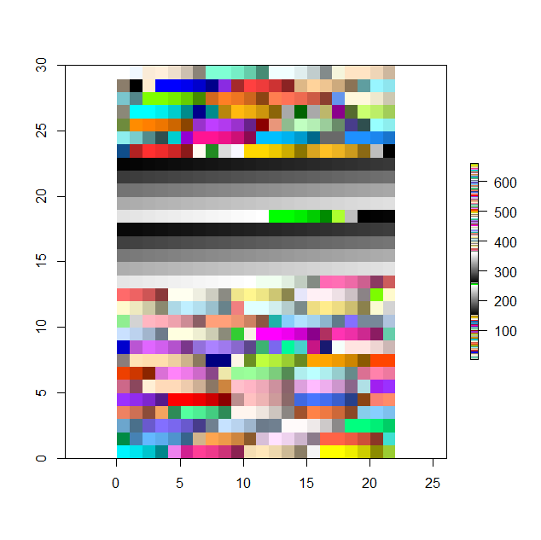

# change the English names of colors into RGB components
# works as well for colors expressed in hexadecimal
col2rgb(c("azure", "azure1", "azure2"), alpha=FALSE)
col2rgb(c("#4B424F", "#BFD15C", "#A44845"), alpha=FALSE)

# display RColorBrewer colours
library(RColorBrewer)
display.brewer.all() # all pallets from the package
display.brewer.pal(11,'Spectral') # displaying the palette
display.brewer.pal(9,'OrRd') # displaying the palette
cols<-brewer.pal(n=5, name="RdBu") # saving selected colors
#[1] "#CA0020" "#F4A582" "#F7F7F7" "#92C5DE" "#0571B0"

# see wensaderson:: colours
library(wesanderson)
cols1<-wes_palette("GrandBudapest1", 4, type="discrete")
cols1
cols2<-wes_palette("GrandBudapest1", 21, type="continuous")
cols2

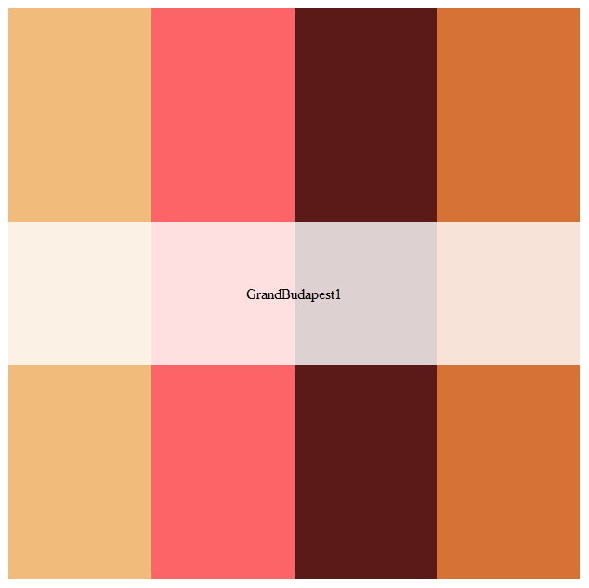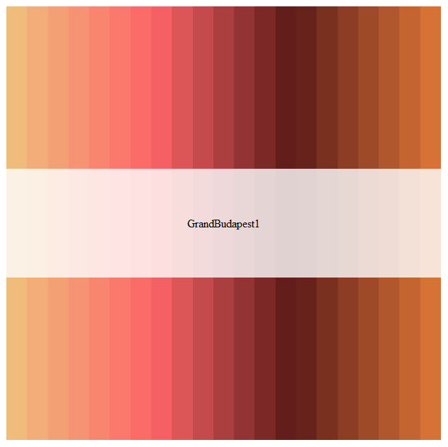

# generate 21 divergent colors with quickPlot::divergentColors()
library(quickPlot)

# palette from the command example
a<-divergentColors("darkred", "darkblue", -10, 10, 0, "white")
a
a.dim1<-length(a)
image(1:a.dim1, 1, as.matrix(1:a.dim1), col=a, xlab="quickPlot::divergentColors() / darkred-darkblue")

# another palette
a<-divergentColors("chocolate4", "peachpuff4", -10, 10, 0, "white")
a
a.dim1<-length(a)
image(1:a.dim1, 1, as.matrix(1:a.dim1), col=a, xlab="quickPlot::divergentColors() / chocolate-peachpuff")
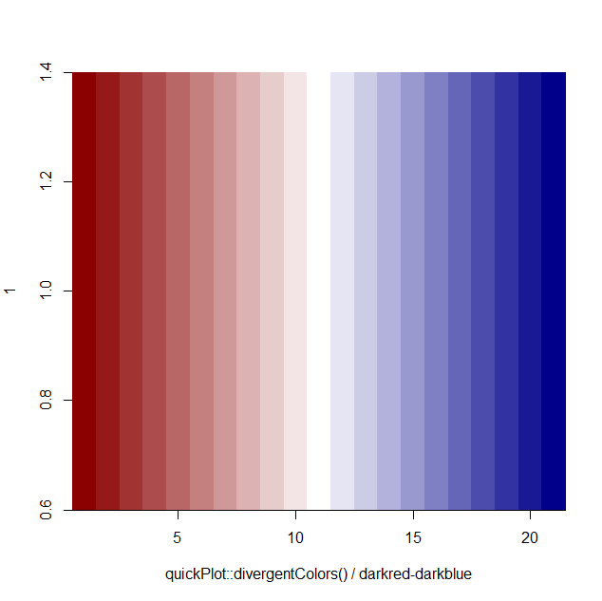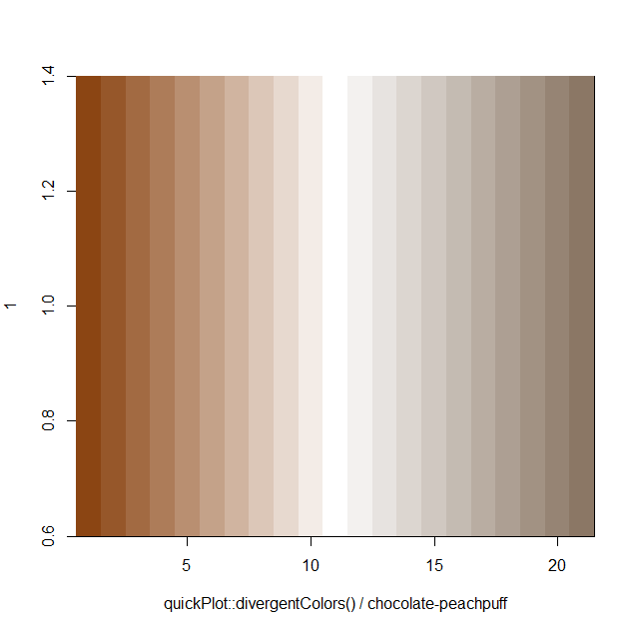

# viridis:: with colours for color-blind people.
# colours divided into five palettes (opt): "magma" ("A"), "inferno" ("B"), plasma (C), viridis (D) and cividis (E)

library(viridis)
library(scales)
viridis.map

col1<-viridis(15, option="D") # the default viridis colors
show_col(col1)

col2<-viridis(15, option="B") # inferno palette
show_col(col2)

# coloured hexagons circled
install.packages("hexbin")
library(ggplot2)
ggplot(data.frame(x=rnorm(10000),y =rnorm(10000)), aes(x=x, y=y)) +
geom_hex() + coord_fixed() + scale_fill_viridis() + theme_bw()

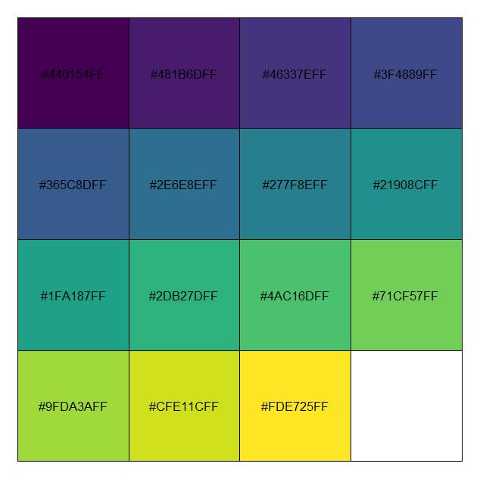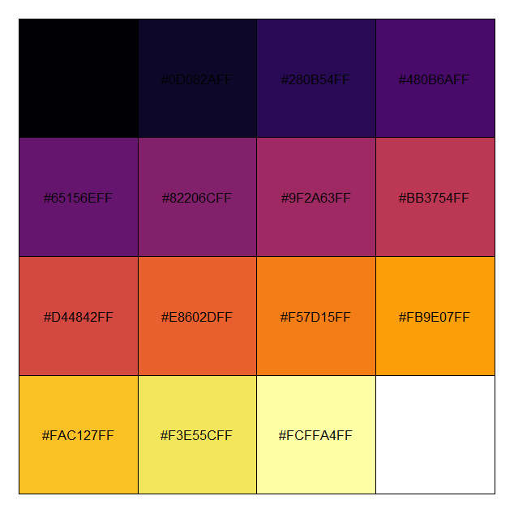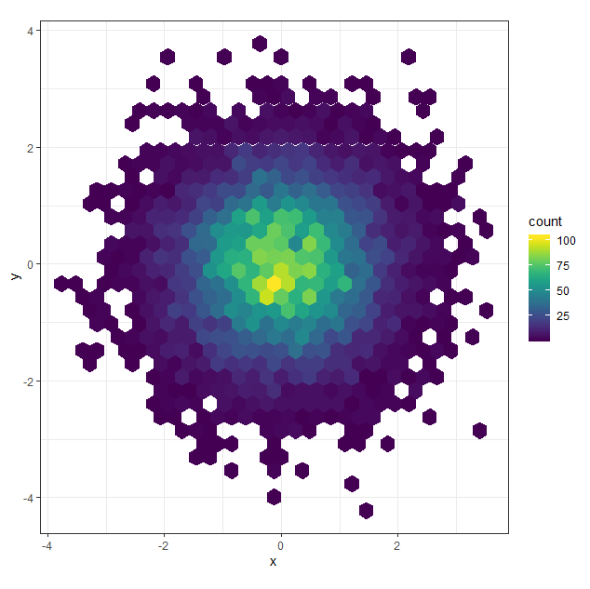

Look also into:
- scales:: - helps in range of color selection and division of variables into ranges, includes data transformations, data management and division into intervals, as well as advanced color management from various palettes.
- colorspace:: - allows advanced color conversions and advanced creation of one’s own palettes.
- smoothScatter() function from the graphics:: package and the colorRamp() and colorRampPalette() functions from the grDevices:: basic package, which return functions that smooth colors and match colors to the next variable values.
- RImagePalette:: - takes colors from the analyzed photo / graph and creates a palette, which allows one to replicate colors.
- quickPlot::getColors() - color management for raster graphics

# Maps with points

# reading point data
firms<-read.csv("geoloc_data_firms.csv", header=TRUE, dec=",", sep=";")
summary(firms)

# scatterplot of empirical data
plot(voi[voi@data$jpt_nazwa_=="lubelskie",])
points(firms$coords.x1, firms$coords.x2, pch=".")

# scatterplot of empirical data with sp:spplot()
firms.lim1<-firms[,c("GR_EMPL", "subreg", "coords.x1", "coords.x2")] # selection of variables
coordinates(firms.lim1)<-c("coords.x1","coords.x2") # class change
spplot(firms.lim1)

# selected variables: x and y coordinates, employment, sector
firms.sel<-firms[1:2000,c(12,13,20,18)] # selected columns
colnames(firms.sel)<-c("x","y","empl","sector") # names change
coordinates(firms.sel)<-c("x","y") # class change
par(mar=c(1,1,1,1)) # chart margins
plot(firms.sel, pch=1, cex=sqrt(firms.sel$empl)/3, axes=TRUE)
v<-c(5,30,150,600) # the scale of the legend
legend("topleft", legend=v, pch=1, pt.cex=sqrt(v)/10, bty="n")
plot(voi[voi@data$jpt_nazwa_=="lubelskie",], add=TRUE, lwd=2)
par(mar=c(5,4,4,2))

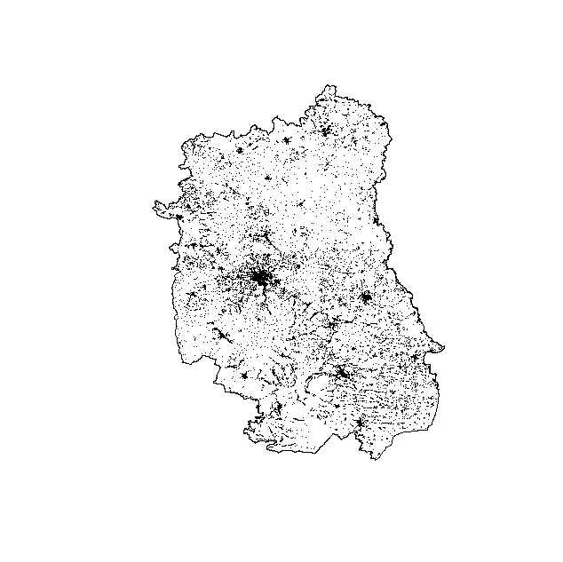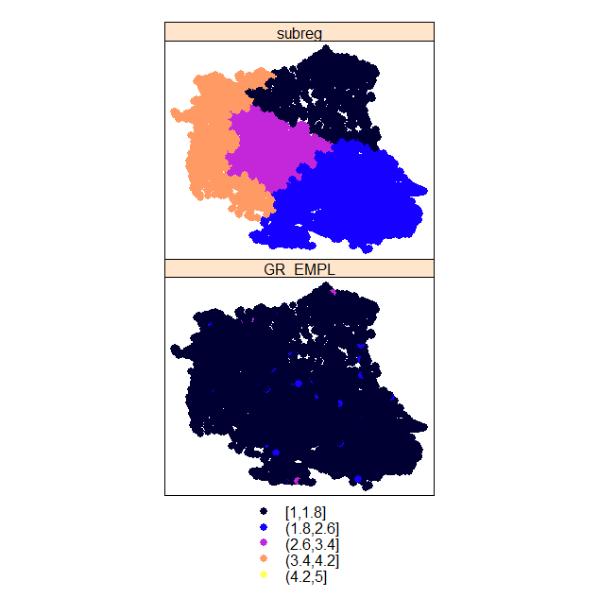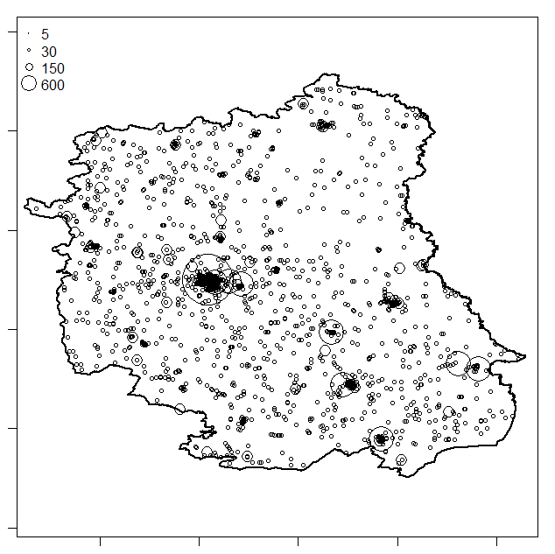

# with findInterval()

variable<-firms$subreg
locs<-firms[,12:13]
summary(variable)
brks<-c(1, 2, 3, 4)
cols<-c("blue3", "cornflowerblue", "seagreen1", "green2")

# limited countour, limited points
plot(voi[voi@data$jpt_nazwa_=="lubelskie",])
points(locs, col=cols[findInterval(variable, brks)], pch=21, cex=0.7,
bg=cols[findInterval(variable, brks)])
legend("bottomleft", legend=brks, fill=cols, cex=0.8, bty="n")
title(main="Points - colors by values")
savePlot(filename="locations and random values", type="jpg")

# poviats represented in centroids
variable<-data$XA14[data$year==2015]
summary(variable)
crds<-coordinates(pov)
brks<-c(60, 80, 100, 120, 140, 160, 180)
size<-(brks/100)*1.2
cols=brewer.pal(7, "Reds")

plot(pov, border="grey90") #Fig.2.10b
plot(voi, border="grey50", add=TRUE,)
points(crds, col=cols[findInterval(variable, brks)],
cex=size[findInterval(variable, brks)], pch=21, bg=cols[findInterval(variable, brks)])
legend("bottomleft", legend=brks, pt.bg=cols, pt.cex=size, bty="n", pch=21)
title(main="Average salary in Poland = 100% year 2015",
sub="In the legend, the interval from …")
savePlot(filename="Average salary", type="jpg")

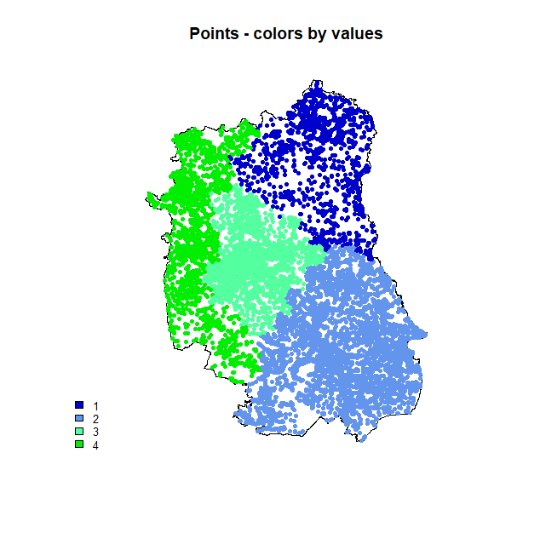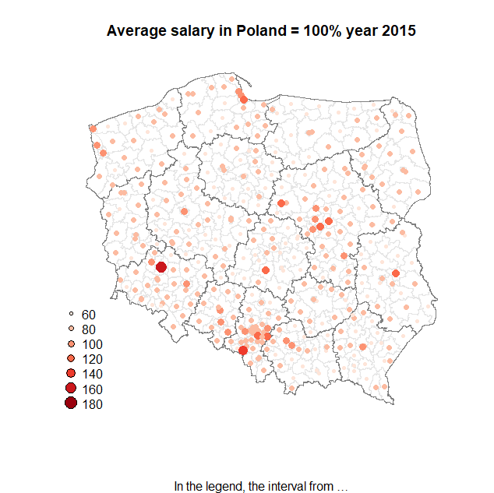

# fragment of the map

# plot a fragment of the map – data, poviat and voivodship of Lubelskie region

# regional map - for the Lubelskie Voivodeship
# version A
voi.df<-as.data.frame(voi)
lub.voi<-voi[voi.df$jpt_nazwa_=="lubelskie", ]
plot(lub.voi, main="Lubelskie NTS2")

# version B
plot(voi[voi@data$jpt_nazwa_=="lubelskie",])

# map of poviats within the Lubelskie Voivodeship
# pov.df<-as.data.frame(pov) # lack of voivodeship identifier
data15<-data[data$year==2015, ]
lub.pov<-pov[data15$region_name=="Lubelskie", ]
plot(lub.pov, main="Lubelskie NTS4")
plot(lub.voi, add=TRUE, lwd=2)

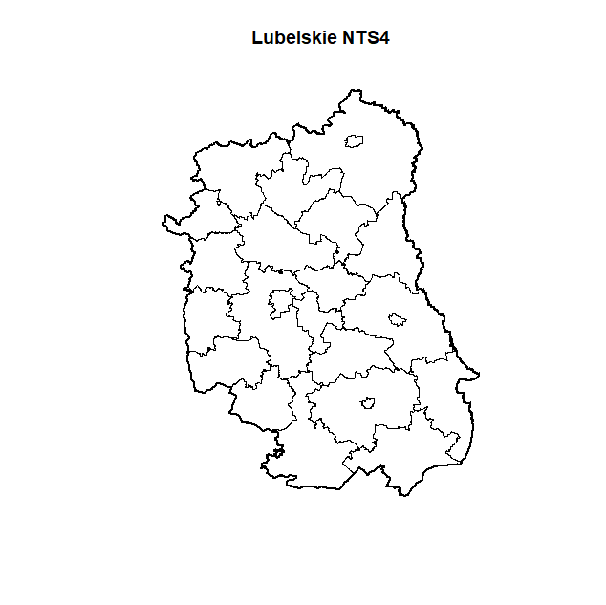

Extra tasks
~~~~~~~~~~~~~~~~~~~~~~~~~~~~~~~~~~~~~~~~~~~~~~~~~~~~~~~~~~~~~~~~~
Plot a contour map of average salary (Poland=100). Label interactively the mostly outlying regions.
~~~~~~~~~~~~~~~~~~~~~~~~~~~~~~~~~~~~~~~~~~~~~~~~~~~~~~~~~~~~~~~~

~~~~~~~~~~~~~~~~~~~~~~~~~~~~~~~~~~~~~~~~~~~~~~~~~~~~~~~~~~~
Plot poviat map for distances between poviats and regional core cities – use palette of grey colours. Erease administrative contours using “transparent” colour. Label the regional core cities.

~~~~~~~~~~~~~~~~~~~~~~~~~~~~~~~~~~~~~~~~~~~~~~~~~~~~~~~~~~~~~~~~~Draw a map of average salary in a selected voivodship, other than Lubelskie. Apply poviat name labels using the text () command.
~~~~~~~~~~~~~~~~~~~~~~~~~~~~~~~~~~~~~~~~~~~~~~~~~~~~~~~~~~~~~~~~~

For point (Lubelskie voivodship) data plot a map of distance between randomly selected 5000 points and powiat cities: Biała Podlaska, Zamość, Chełm, Lublin. Connect the points with the nearest cities. Add poviat countours. Use spDistsN1() command.

Let’s use over(). Below you have the structure of the code, which needs some corrections. The goal is to plot in red the points, which belong to selected municipality (gmina).

# structure of the code
pov.sel<-pov[data15$poviat_name1=="Powiat Lublin",]
firms.sp<-firms
coordinates(firms.sp)<-c("coords.x1","coords.x2") # class change
proj4string(firms.sp)<-CRS("+proj=longlat +datum=NAD83")
pov.sel<-spTransform(pov.sel, CRS("+proj=longlat +datum=NAD83"))
firms.sp<-spTransform(firms.sp, CRS("+proj=longlat +datum=NAD83"))

# method with over()
locs.lim<-over(firms.sp, pov.sel)

par(mar=c(1,1,1,1))
plot(voi[voi.df$jpt_nazwa_=="lubelskie",])# plot of whole voivodeship
locs<-firms[,12:13] # all points of the class data.frame
points(locs, col="grey80", pch=".", cex=0.7) # plot of all points
points(locs[locs.lim$jpt_nazwa_=="powiat Lublin",], pch=".", cex=1.1)
plot(pov.sel, add=TRUE, border="red") # plot of selected poviat
par(mar=c(5,4,4,2))

